**What is flex-box in css**

[Flex-box](https://developer.mozilla.org/en-US/docs/Web/CSS/CSS_flexible_box_layout) is a one-dimensional layout method for arranging items in rows or columns.

## [Why Flexbox?](https://developer.mozilla.org/en-US/docs/Learn/CSS/CSS_layout/Flexbox#why_flexbox)

For a long time, the only reliable cross-browser compatible tools available for creating CSS layouts were features like [floats](https://developer.mozilla.org/en-US/docs/Learn/CSS/CSS_layout/Floats) and [positioning](https://developer.mozilla.org/en-US/docs/Learn/CSS/CSS_layout/Positioning). These work, but in some ways they're also limiting and frustrating.

Parent element (Flax Container)

By default horizontal direction is called **main-axis**

By default vertical direction

is called **cross-axis**

Child element

(Flax-item)

Child element

(Flax-item)

Child element

(Flax-item)

Display : flax; -: this properties is use to makes flexible container . and By default our item set to row direction.

**Flex-direction properties**

The flex-direction property defines in which direction the container wants to stack the flex items. By default this is set to row direction.

**Four properties of flex-direction**

* flex-direction: row;
* flex-direction: row-reverse ;
* flex-direction: column;
* flex-direction: column-reverse ;

**flex-direction: row;**

The row value stacks the flex items horizontally (from left to right):

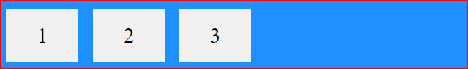

**flex-direction: row-reverse ;**

The row-reverse value stacks the flex items horizontally (but from right to left):

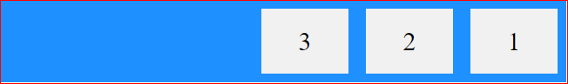

**flex-direction: column;**

The column value stacks the flex items vertically (from top to bottom):

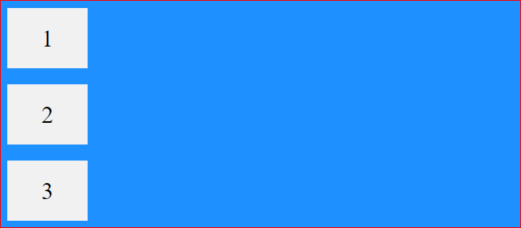

**flex-direction: column-reverse;**

The column-reverse value stacks the flex items vertically (but from bottom to top)

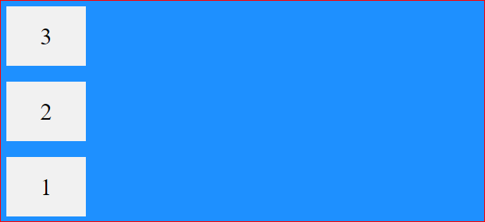

**Flex-wrap properties**

The flex-wrap property specifies whether the flex items should wrap or not(means when decrease the view port size in that case box size are not decrease)

**Four properties of flex-wrap**

* flex-wrap: nowrap; when decrease the view port size in that case box size are automatic decrease
* flex-wrap: wrap; when decrease the view port size in that case box size are not decrease
* flex-wrap: wrap-reverse;

**The flex-flow Property**

The flex-flow property is a shorthand property for setting both the flex-direction and flex-wrap properties.

*<*style*>*

 .container {

 display: flex;

 flex-direction :row;

 flex-wrap: wrap;

         }

*</*style*>*

*<*style*>*

.container{

 display: flex;

 flex-flow: row wrap;

}

*</*style*>*

**Shorthand property**

**Justify-contents properties**

It is used to place the item accordingly to main axis.

main axis

if flex-direction -> row -> main axis -> horizontal

if flex-direction -> column -> main axis ->vertical

**Justify-contents properties has 6 value**

justify-content: center;

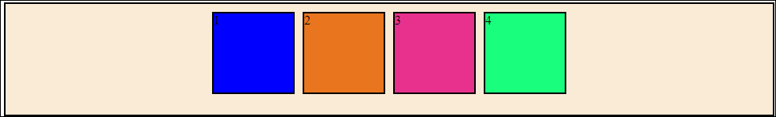

justify-content: start/left;

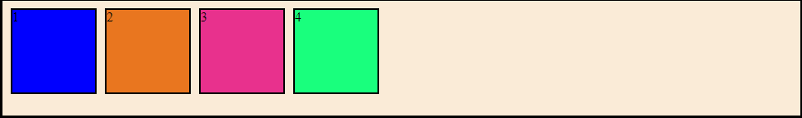

justify-content: end/right;

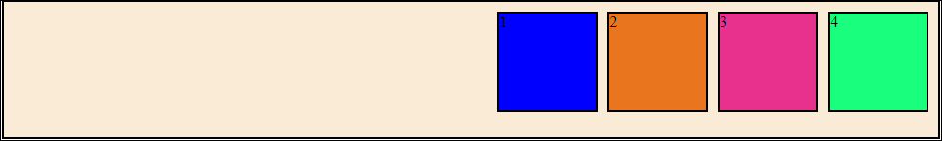

justify-content: space- between; in space-between all have contain equal space from first box.

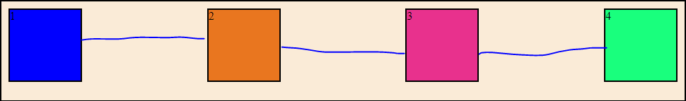

justify-content: space- around; in space-around all box have equal space in both left and right side

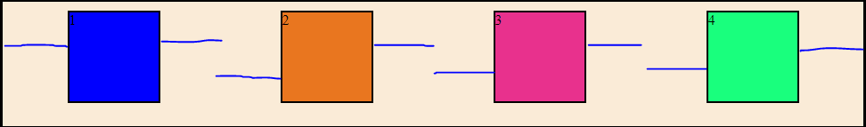

justify-content: space- evenaly; in space-evenly all box have equal space from the border container.

